[](https://www.holidify.com/)

[](https://play.google.com/store/apps/details?id=com.holidify.andorid.app.holidify&referrer=utm_source%3Dblog%26utm_medium%3Dheader)

* [Blog Home](https://www.holidify.com/blog)
* [Get Customized Packages](https://www.holidify.com/custom-package/?utm_source=blog&utm_medium=header&utm_campaign=test)
* [Collections ▼](https://www.holidify.com/blog/most-haunted-places-in-india-asi-list/)



[35 Most Haunted Places in India: Real Stories and places](https://www.holidify.com/blog/most-haunted-places-in-india-asi-list/)

[Adventure](https://www.holidify.com/blog/category/adventure/) · [Collections](https://www.holidify.com/blog/category/collections/) · [Haunted Places](https://www.holidify.com/blog/category/collections/haunted/) · [Natural Wonders](https://www.holidify.com/blog/category/natural-wonders/)

**[Facebook](https://www.holidify.com/blog/most-haunted-places-in-india-asi-list/" \o "Share this post on Facebook!)** **[Google+](https://www.holidify.com/blog/most-haunted-places-in-india-asi-list/)** **[Twitter](https://www.holidify.com/blog/most-haunted-places-in-india-asi-list/" \o "Share this post on Twitter!)**

The mysteries of the unknown have always fascinated the human mind. It’s not surprising for experts to say that India is a beautiful yet deliciously **mysterious country** that beholds the secrets and stories of a lot of palaces and their kings, of treasures and their keys, of those who died a painful death and are now a part of the broken synchrony that is reality. Which is why a lot of forts or palaces or beaches or even a ‘just another’ valley in India has a history or a twist of mystery attached to it or something which makes a more interesting case.

Are you fond of the unknown? Do you remember the **Zee Horror Show** or the **Aahat**?

If you are one of those who love to turn the pages long sealed and kept hidden from the human eye, if the word ‘**supernatural**‘ gives you an adrenalin rush, you, my friend, like me and many others, are someone who likes to push the boundaries a little and take a peek into what’s happening in the strange, mysterious world out there. This post is for all the travellers who are done with the monotony of life and are looking forward to exploring the **unexplored**.

*Some tales can be stranger than fiction, which is why I say – At your own risk!*

Here’s a wiki list of the 35 such haunted places in India carefully mapped out for your benefit.

1. Bhangarh Fort – Ajabgarh, Alwar, Rajasthan

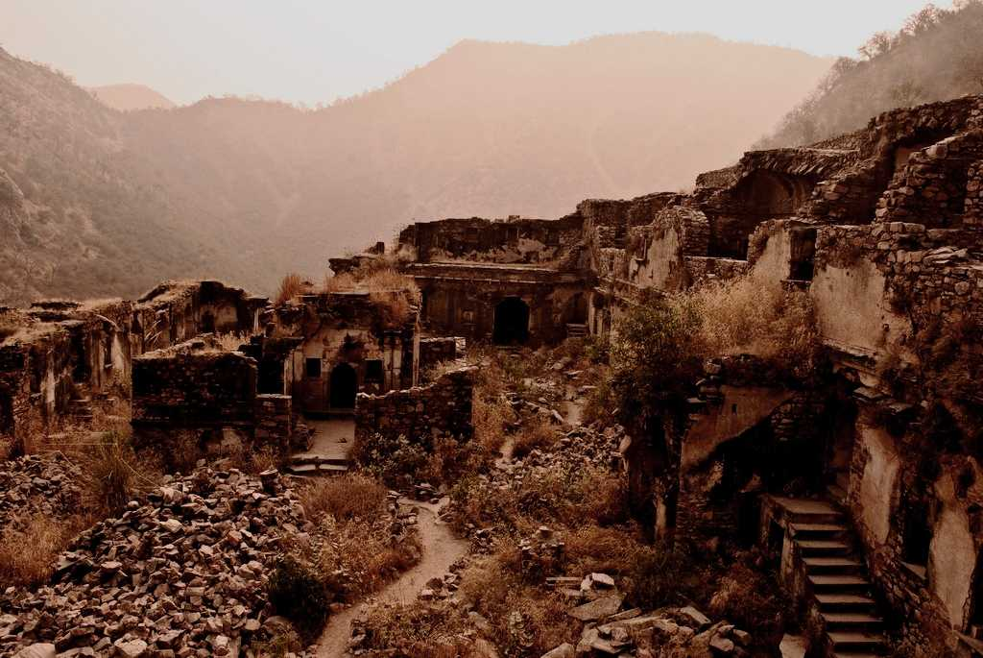

Bhangarh Fort ([Credits](https://www.flickr.com/photos/parthjoshi/6659492837/in/photolist-b9tDd2-b9tzN2-b9twC4-b9tuav-b9trmZ-b9toCH-b9tkYn-b9tgRk-b9te92-b9tbpZ-b9t4w6-b9t1c6-b9sXAM-b9sV22-b9sQwe-b9sM8F-b9sJtg-b9sHPk-b9sFtx-b9sDtg-b9sBxe-b9szVv-b9syer-b9sw8F-b9stEP-b9srXM-b9spQp-b9snXV-b9skDe-b9siXK-b9shRa-b9sfNk-b9sdWH-b9sbWH-b9sa2V-b9s8xV-b9s6AT-b9s4VK-b9s2UK-b9s1kB-b9rY7v-b9rVbg-b9rU1g-b9rPxF-b9rMdr-b9rJKM-b9rGTT-b9rF22-b9rCE4-b9rA7a" \t "_blank))

The ghost town of [Bhangarh](https://www.holidify.com/alwar/sightseeing-and-things-to-do.html" \l "Bhangarh Fort" \t "_blank) is one of the ***scariest, spookiest places*** you could possibly imagine, not to mention, one of the **most haunted places in India**. Situated near a popular forest, this town is now slowly luring visitors from around the area, and country, for all the wrong reasons.  
It should be noted that if you decide to visit this place after the sun has gone down, you won’t be allowed to. In fact, there is a strict warning about how **dangerous** this place becomes after sunset.  
The story which this town is well-known for tells the tale of a *magician who fell in love* with the local princess of the area even though their match was impossible. Being quite the master of **dark magic**, he decided to cast a spell on her to make her surrender to him. However, the princess learned of his plans and found a way to kill him. Before his death, however, the magician cast a dark spell on the palace which caused its doom.  
Despite Bhangarh Fort being regarded as one of the**most horror haunted places in India** has been officially promoted as a **tourist destination**. However, once the night falls and the darkness takes over, this place becomes deserted, leaving it prey to the supposed ‘supernatural’. **The mystery of Bhangarh Fort** also featured on a TV show and you can have a look at the **most haunted place in India’s video** yourself. (link at the bottom)

[Most Haunted Place in India’s Video](https://www.youtube.com/watch?v=3Sr7KsfAFgI" \t "_blank)

[Find more Hidden Destinations in India, visit Holidify.com](https://www.holidify.com/)

2. Kuldhara – Rajasthan

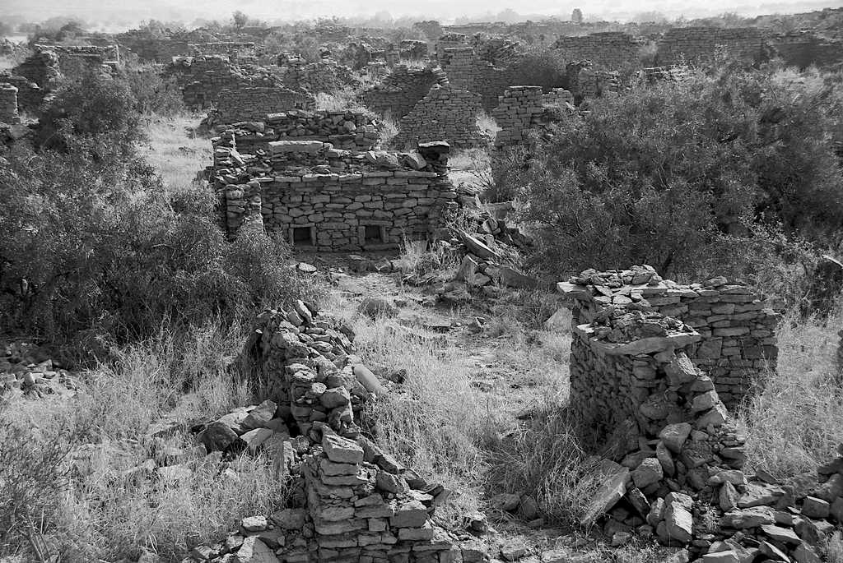

Remains of the abandoned village ([Credits](https://www.flickr.com/photos/gusilu/5306247514/in/photolist-95TUw7-95TVDW-95TVxJ-95TVnG-95QT1n-95QSTg-95TURW-95QSse-95TUou-95QRZ6-7RSwT9-7RSv5L-7RSu21-7RPdeH-7RSrxh-7RSqkb-7RPiN6-7RPgtF-7tp2Ad-95TUgy-7tem14-dGRdYg-dGWGgm-dGRgoz-dGRgcc-dGWFRY-dGRfYx-dGWFE5-dGWFxo-dGRfBP-dGRfsT-dGRfor-dGRfj6-dGWEWm-dGWEPw-dGReXx-dGReRn-dGReDz-dGRevM-dGRerP-dGWE2G-dGRebM-dGWDQb-dGRdS6-dGWDwf-dGRdGv-dGRdAt-dGRdsp-dGWDbh-dGRdhZ" \t "_blank))

The village of **Kuldhara** is popularly known to be a deserted ghost village that has been **abandoned since 1800s.** It is said to carry a curse of the villagers who vanished from there overnight, after having lived there for over 7 centuries.  
The village lies in **ruins**, established in 1291 by the Paliwal Brahmins, who were a very prosperous clan and were known for their business acumen and agricultural knowledge. It has been said that one night in 1825 all the people in Kuldhara and nearby 83 villages vanished in dark. All of a sudden and without any **warning**.  
Tales about this mystery include the fact that Salim Singh, the minister of the state, once visited this village and fell in love with the beautiful daughter of chieftain wanting to marry her. The minister threatened the villagers by saying that if they did not marry the girl to him, he would levy huge taxes. The chief of the village along with those of adjoining villages decided to abandon and migrate elsewhere to protect the girl’s honour. Nobody saw them leave nor did anyone figure where they went, they simply vanished. It is said that the villagers also cast a spell on the village as they left, cursing anyone who tried to inhabit the land.

3. D’Souza Chawl in Mahim – Mumbai

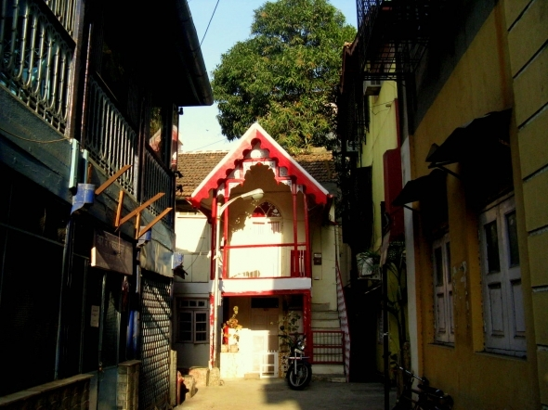

D’Souza Chawl

Owing to **D’Souza Chawl, Mahim** has acquired the status of being the **most haunted place in Mumbai**. It is said that a **woman fell into the water** and died crying for help in the well. Probably that is why most people say that they’ve witnessed a woman lurking around the well and the nearby area.

4. The Shaniwarwada Fort – Pune

[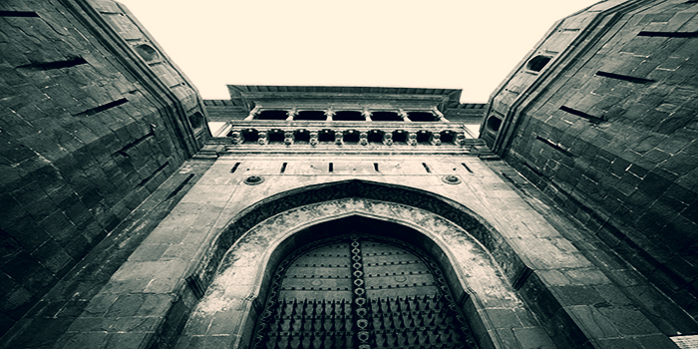](https://www.holidify.com/blog/wp-content/uploads/2015/08/shaniwar-wada-fort.jpg)

The imposing gateway of Shaniwarwada Fort. courtesy: Vargis Khan

Known for its sheer architectural brilliance, this fort has witnessed various **spooky occurrences**. It is believed that the level of supernatural activity is on its zenith on every full moon night. The **mysterious** story behind the strange activities suggests that *a young prince was brutally murdered here* which is maybe why his spirit haunts the place and when the night falls, sounds of him shrieking can be heard. There are many locals who actually camp at night on the fort grounds just to hear the little boy’s scream.  
It is preferable to visit the fort during day hours since the fort is **deserted at night** except for maybe a caretaker. Visit this place at your own risk as this would definitely be the **scariest haunted place in Pune, India.**

5. GP Block – Meerut

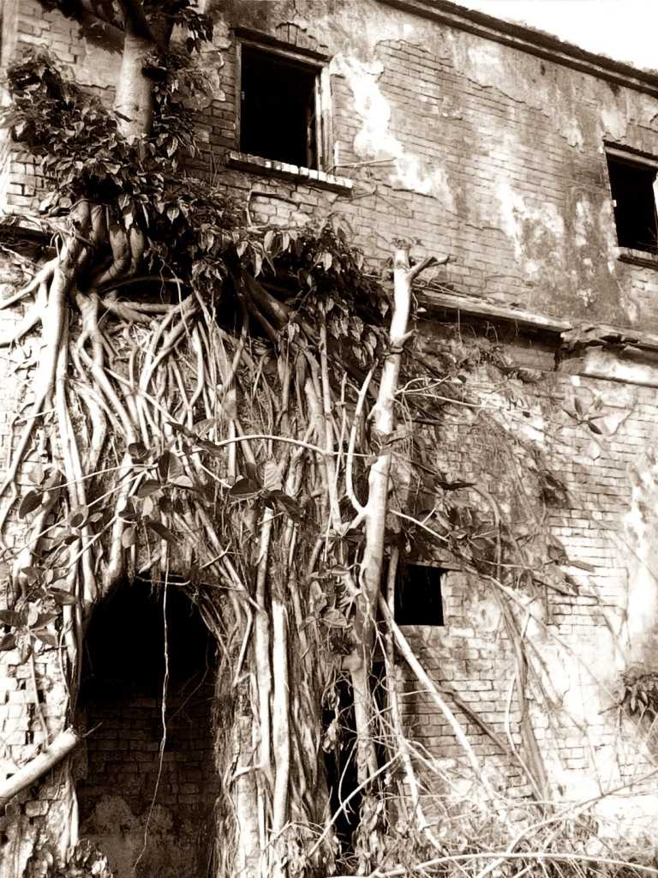

The haunted house at GP Block Meerut

**GP Block in Meerut** is also very notoriously known for all the **paranormal activity** it beholds. Despite being a popular zone, there have been reportedly a lot of **strange sightings**.  
For instance people who pass this place claim to have seen four males sitting together and enjoying an alcoholic beverage by the light of a single candle. At first, this was not considered **spooky** for it could just be four friends having a good time but once it was established that it was indeed four ghosts, people in and around the area became increasingly interested. In addition, some claim to also witness a young girl coming out of the house in what many people believe to be a red dress. With time people have abandoned that place for obvious reasons but it continues to catch the fancy of those who love the **paranormal**.

6. The Vrindavan Society – Thane

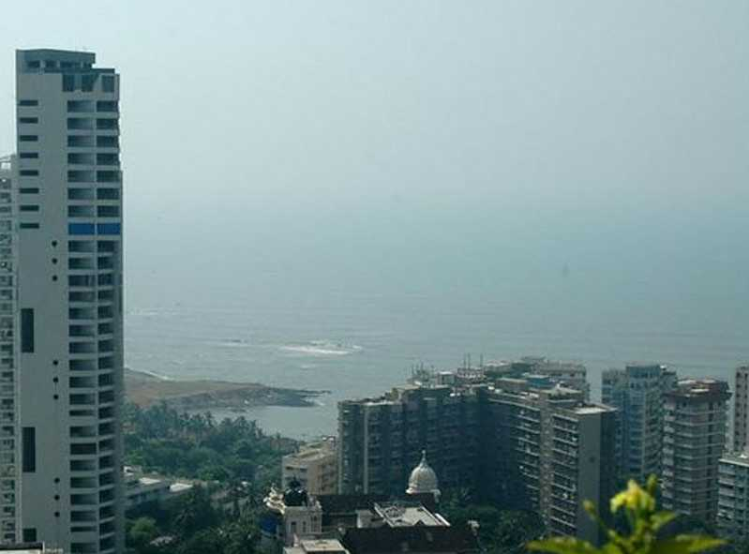

People in houses are not the only residents in this society

Considered to be of the most famous housing societies of Thane, this society is also home to a bit of paranormal. Many of its residents and night watchers have experienced what may only be termed as strange and bewildering.  
This society however doesn’t look like it is **haunted place**, in fact it was known for its luxurious apartments.  
Anyway, it has been reported that there was once a man who lived in the society **who happened to commit suicide**. His spirit is said to haunt the society once the hours turn dark. In fact, the night guards have witnessed a lot of strange activities which have also included a guard getting slapped in the face with such force that he nearly toppled from his chair. Immediately afterwards both the guards searched the whole society and they could not find anyone around.  
This incident instilled fear in the minds of the residents who are careful not to enter the society too late in the night. However, the housing society still remains occupied even though the**paranormal activities** continue to haunt the residents and guards.

7. Dumas Beach, Surat- Gujarat

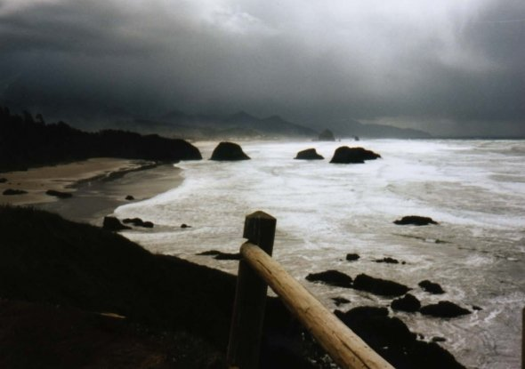

Dumas Beach near Surat

Situated along the Arabian Sea in **Gujarat**, this beach is known for its **black sand** and mystical activities.  
Many unexplainable and puzzling incidents have been known to occur like strange whispers being heard, people disappearing during night etc.  
In fact, it is believed that a lot of people have lost their lives exploring this **mysterious** beauty.  
If you are a brave heart, you can test the waters yourself by taking a midnight stroll along the beach, if you have company. If the testimonies are anything to go by, you will also be greeted by warnings asking you to not cross a certain line while on the beach. It is also believed that this beach was for long used as a Hindu burial ground, therefore, being the resting place of tortured souls. There have also been reports of people disappearing mysteriously and having never been found again. However, if you still feel you would want to go for it then by all means. If you love the **paranormal** you would definitely have the time of your life.

[Find more Hidden Destinations in India, visit Holidify.com](https://www.holidify.com/)

8. Jatinga – Assam

Jatinga

Having a population of around 2500, this village is popular worldwide for its unexplained phenomenon of **bird suicides**. Most of the migratory birds visiting the area never leave the village, **dropping dead for no rhyme or reason** on the streets. The case gets even more inscrutable as these birds always plummet to their death between 06:00 p.m. to 09:30 p.m. on the moonless nights of September and October.  
These **mass suicides** only occur on a specific 1 mile by 600 feet strip of land and this phenomenon is said to have occurred year after year without a break for more than a century. Many theories have been offered by scientists to explain this phenomenon, the most popular one being that these birds are attracted towards village lights which later confuse them, along with many others.  
None of them have yet been able to prove any of the theories behind this phenomenon though, which is why it continues to haunt and intrigue the minds of the residents and travellers just the same.

9. Ramoji Film City – Hyderabad

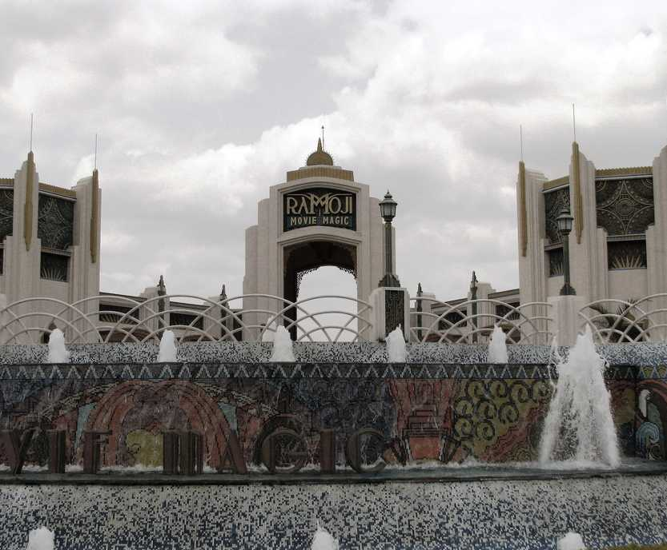

Ramoji Film City ([Credits](https://www.flickr.com/photos/mckaysavage/3920732198/in/photolist-cWbRiQ-hGrmU-6Ypbtn-93Nwoj-6YsYbJ-hGqPZ-6YsM61-MgXzj-56eA3J-56areM-56eATL-6Ypave-56aqZH-56eAbf-56armz-7rZ6aj-7rZ7gW-7rVayr-7rV8dX-38q7wT" \t "_blank))

Being one of the biggest film cities in the country, this place is home to a lot of hotels which have been projected to a lot of controversy because of the reported “**supernatural activities**” in and around them.  
Witnesses report the lights kept on top keep falling off, the light men- who sit with the lights on top have been pushed so many times and many have had grievous injuries. The food left in rooms also gets scattered around the room and **strange marks** are left on the mirrors.  
Females are more targeted by the **ghosts** than the males. Girls reported an invisible force tearing their clothes off, some said they felt someone knock their washroom doors while the rooms remain locked from the inside. They create havoc. Many preventive measures have been taken but in vain. **Must visit** haunted place in India in case you want to experience the **paranormal**for yourself.

10. Raj Kiran hotel – Lonavla, Maharashtra

[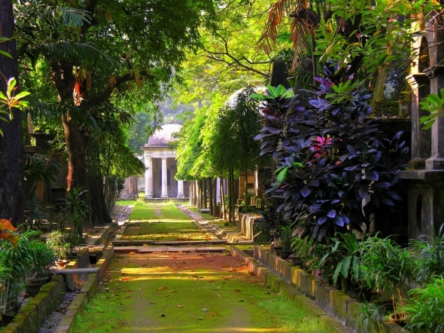](https://www.holidify.com/blog/wp-content/uploads/2015/08/Raj-Kiran-Hotel.jpg)

Raj Kiran Hotel

This haunted hotel in India was reported to be one of the hit zones as far as the “**super natural**” is concerned. Residents of one particular room in this hotel claimed to have their bed sheets pulled over and stayed put in such state long after they’d leave the bed in a scare. Some people recount having woken up in the middle of dark nights with a ray of blue light at their feet. This room is in the corner and at the backside of the reception on the ground floor itself.

11. Sanjay Van (near Qutab Institutional Area) – New Delhi

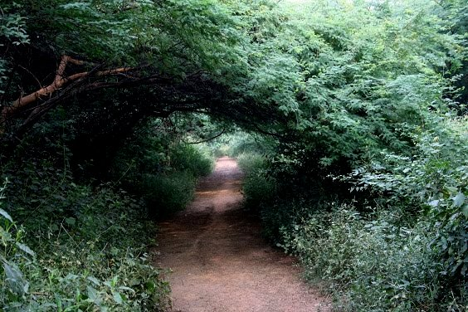

Sanjay Van, Delhi

Sanjay Van is a huge forest area spread over around 10 kms. People have reported having seen a **lady dressed in a white saree**appearing and disappearing suddenly around the cremation ground near that area. No wonder this area is regarded as **most haunted place in Delhi**. Make sure that you are not alone here, especially after the dark.

12. Dow Hill in Kurseong – Darjeeling

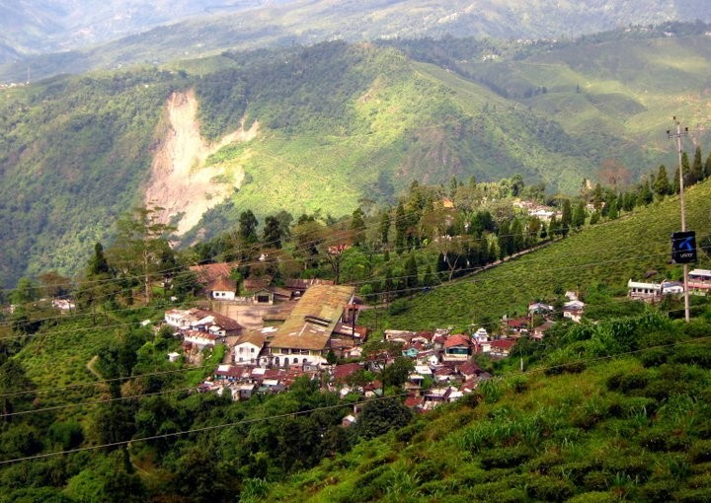

Kurseong

Dow Hill might not be a very sought after place but is definitely one of the **most haunted places in India.** The Dow Hill Boarding School for Girls is very well known for **spooky activities** bordering on the **paranormal**. There have been reports talking of *ghostsightings.* Also, the forest that surrounds the school is considered to be haunted. In fact, many woodsmen who visit the forest have reported seeing a headless boy who suddenly appears and then disappears into the forests. Legend has it that there were **innumerable murders** which took place in this forest area. That says more than required on the matter.

[Find more Hidden Destinations in India, visit Holidify.com](https://www.holidify.com/)

13. The Brij Raj Bhavan Palace in Kota – Rajasthan

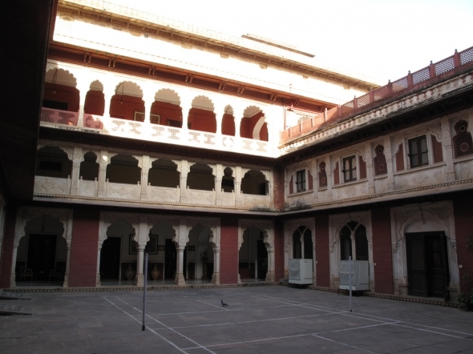

Brijraj Bhawan Palace, Kota

The Brij Raj Bhavan Palace in **Kota** should definitely be on your list being one of the **most ‘ghostly’ places in India.** This old palace converted into a heritage hotel is apparently **haunted** by a **British ghost** who was killed during the Revolt of 1857. There are some who also add that Major Burton (the ghost) along with his sons was shot right inside the palace and therefore, he **haunts the place.** In fact, in this palace, considered by many as one of the **most mysterious and hanuted places in India,** the ghost of the Major doesn’t really harm anyone, but the night guards claim to have been slapped by an invisible hand in the middle of the night.  
The perfect place to visit if you want to **explore the unknown** and stay out in the clean.

14. Agrasen ki Baoli, Hailey Road, New Delhi

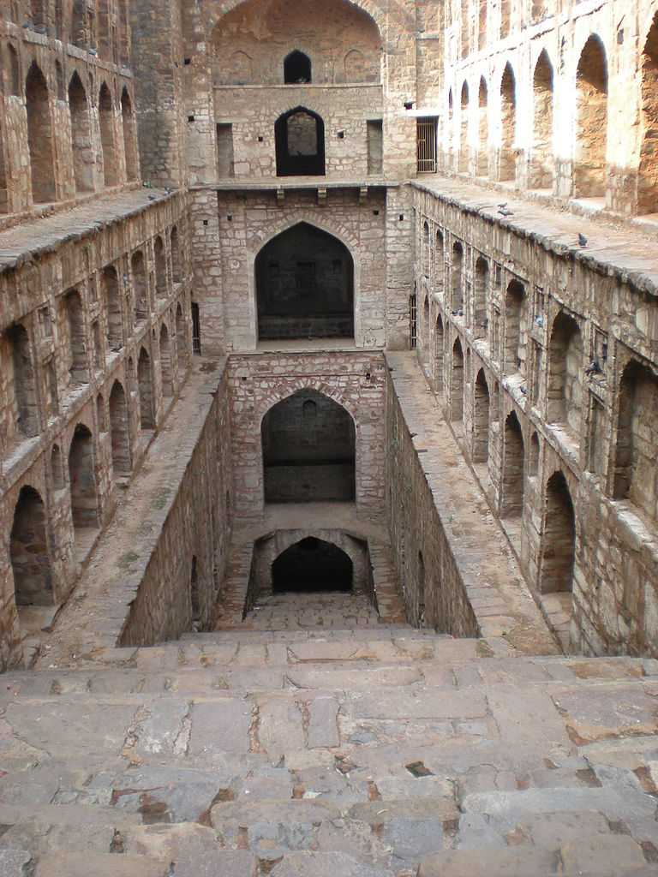

Agrasen ki Baoli

An Ancient Step Well situated right in the heart of central [Delhi](https://www.holidify.com/delhi" \t "_blank) takes you by surprise if you are out on the streets for a walk. Ironically, it is actually quite impossible to miss having a unique blend of architecture with a signature design known to have existed only centuries ago. Although there are no known historical records to prove who built the beautifully designed step well, it is under the **protection of ASI** for being a rare historical specimen, one of its kinds.  
It is not known for any kind of **supernatural activities** but for its **mystic feel** and the **hearsay stories** about how some felt like they were being followed by an **invisible somebody** and the intensity of the same increased if they started walking faster. This is definitely something you need to experience first hand to really believe it.

15. Bengal Swamps – West Bengal (Aleya Ghost Lights)

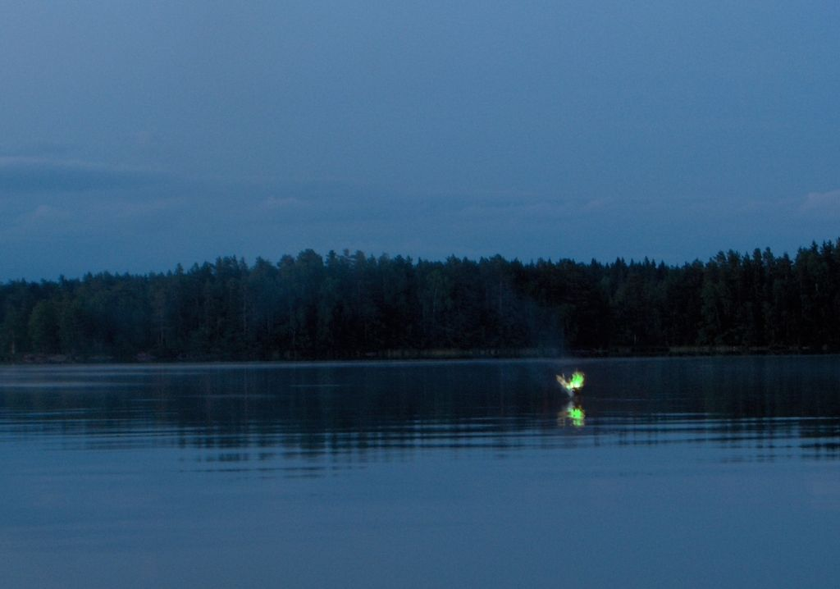

Bengal Swamps, West Bengal

Aleya lights also known as **marsh ghost lights** are the unexplainable ghost lights reported in the marshes generally by the local fishermen. These lights are said to confuse fishermen causing them to lose their bearing. It may lead to drowning if one starts following these lights moving over the marshes. Many bodies have washed ashore on these swamps that locals attribute to Aleya lights. Residents believe that these strange hovering marsh-lights are in fact ghost-lights representing the **ghosts of fisherman**who died fishing. Sometimes they confuse the fishermen while sometimes they help them avoid future dangers.

16. Fernhill Hotel, Ooty

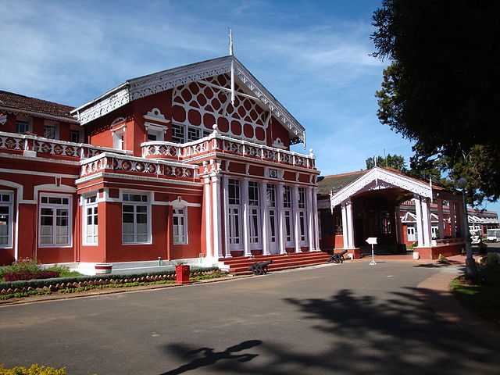

Fernhills Palace, ([source](https://upload.wikimedia.org/wikipedia/commons/thumb/1/1d/Fernhills_Palace%2C_Ooty.JPG/800px-Fernhills_Palace%2C_Ooty.JPG" \t "_blank))

Frenhill Hotel, which is now shut down after re-occurrence of haunting events, gained much name after  spooky incidents during the shooting of movie Raaz.  “Once Sarojji and her troupe checked in late at night and were kept awake by someone rearranging furniture in the room above. The dancers who had an early morning shoot tried calling reception but the phone was dead. Desperate for sleep, some went down to complain, only to have the receptionist escort them outside and point upwards to show that there was no floor above” Said Bipasha.

17. Mukesh Mills

[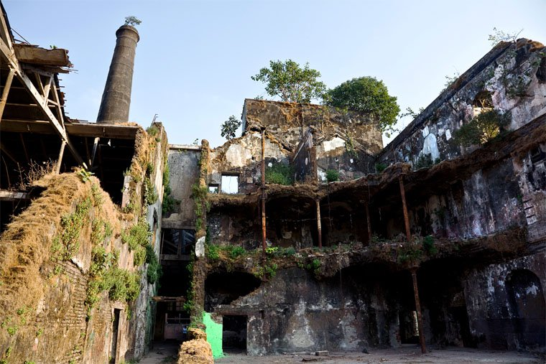](https://www.holidify.com/blog/wp-content/uploads/2015/08/mukesh-mills.jpg)

Mukesh Mills, Mumbai

The mill was shut down in 1980 after a sudden fire outbreak. This abandoned haunted place in India serves as an excellent location for shooting Bollywood horror movies. However, some directors as well as actors refuse to shoot here after experiencing paranormal activities.

18. National Library Kolkata

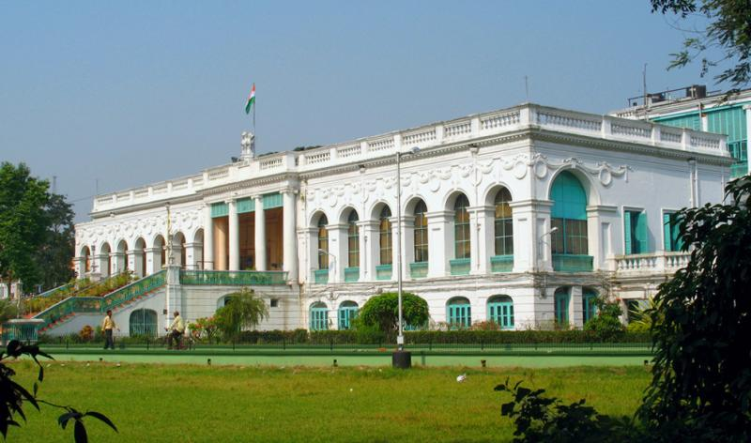

National Library, Kolkata ([source](https://www.flickr.com/photos/avramitra/2105418540/in/photolist-4d3PzE-f9cs8K-7rT8v" \t "_blank))

Besides rich collection of books, The National Library, Kolkata is also known for its ghost stories. At the time of its renovation, twelve labours lost their lives in an accident.  The stories of an unnatural death of a student while searching books and lot more. The guards often fear to take up the nights shifts. It is also said that the footsteps of the Governor’s wife can be still heard.

19. Sanjay Gandhi National Park, Mumbai

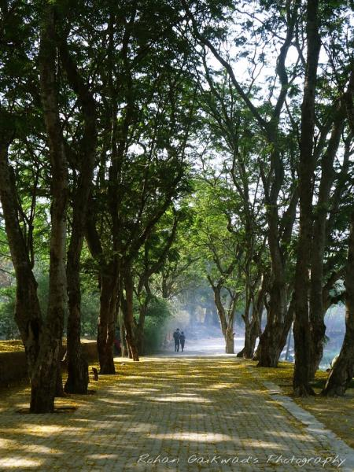

Sanjay Gandhi National Park ([source](https://www.panoramio.com/photo/105543091" \t "_blank))

Many people who visit this national park, claim that they saw a female hitchhiker who is dressed in all white, and is asking for a ride to anyone who passes by. The testimony of the guards working in the National Park, who say that ghosts really exists there makes its way too eerie.

20. South Park Cemetry, Kolkata

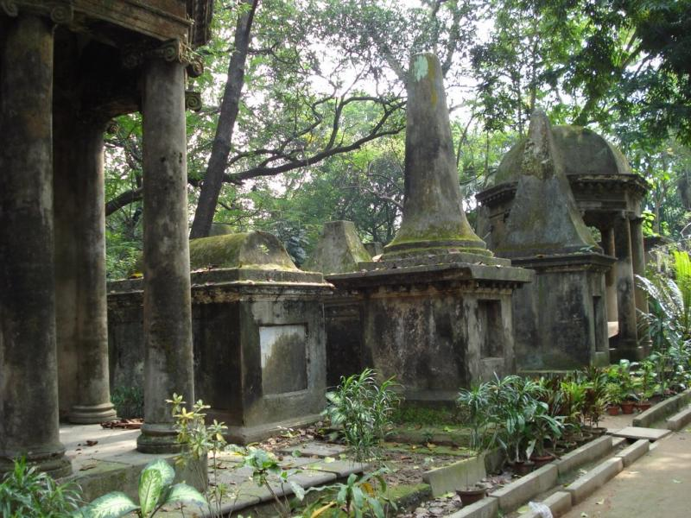

South Park Cemetry ([source](https://www.panoramio.com/photo/6221653" \t "_blank))

Its one of the oldest cemetery build in the year 1767. Many people have reported that they have seen a shadow in white dress and some even fell ill after visiting this haunted place.

21. Writers building, Kolkata

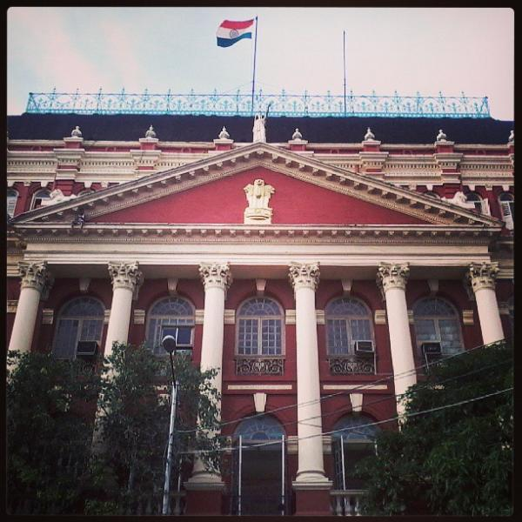

Writer’s Building, Kolkata ([source](https://www.flickr.com/photos/52442953@N05/9534287871/in/photolist-ojQ4cR-oD5uS6-jwrs79-qML4oc-r5dC2r-fwvHBD-ojQef5-4dBXqn-jwqB4Z-qMCz6d-qML3WR-r54CM8-r58J43-qMDWtU-qMDXcs-r5dzfz-q8cY1q-qMMLoe-qMML6a-r58JMY-qMMJ7R-q8cZGG-r2VhDA-q8d18G-qMMM5p-r54Ac8-q8d1jo-qMDVXd-qML2sP-qML2aV-r54BVt-r5dz9n-q8qyw4-qMDYSw-5ZdDDx" \t "_blank))

The new Writers Building is constructed inside the old fort after the first one got demolished a natural disaster. It is believed that the spirit of Captain Simpson of British East India Company, who was killed by the revolutionaries Binay, Badal and Dinesh, still resides in the building. People residing in the nearby premises often hear the footsteps and voices after its dark.

22. Bombay Supreme Court

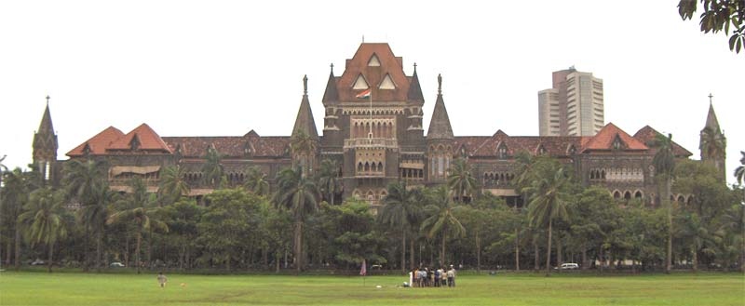

Bombay Supreme Court ([source](https://upload.wikimedia.org/wikipedia/commons/1/15/Bombay-High-Court.jpg" \t "_blank))

A tortured, vengeful soul is believed to haunt every unknown entity in the corridor restricting their entry. This happened since last 30 years whenever a murder trial is taking place.

23. Delhi Cantonment Area

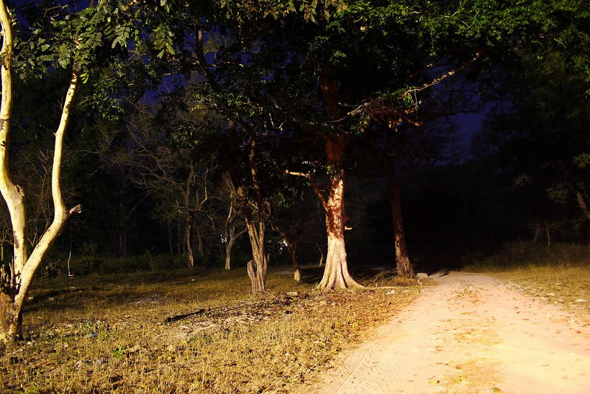

The lonely stretch of road in Delhi Cantonment ([source](http://blog.taxiforsure.com/wp-content/uploads/haunted-places-in-delhi-delhi-cantt.jpg" \t "_blank))

Usually considered as a beautiful clean and green space, Delhi cantonment area is also known as haunted place its spookiness after mid night. People talk about a women in white saree, often asking for lift, sometimes even chasing the vehicle and catching up its speed.

24. Towers of Silence, Mumbai

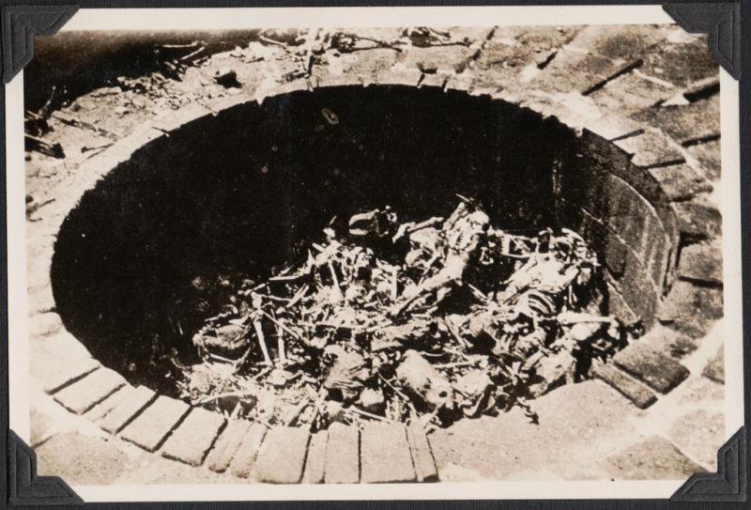

Tower of Silence, Mumbai ([source](https://c4.staticflickr.com/4/3718/12450025503_f548edc141_b.jpg" \t "_blank))

It is actually a Parsi cemetry situated near the Malabar Hills. Parsi’s have the ritual of leaving the bodies of their dead on the roof top of a tower to be fed by the vultures. Even the imagination of those scenes would bring shivers to your body. It is also believed that the paranormal incidents occurring in Grand Pararri Towers in Mumbai happens due to the spectral forces emanating from this cemetery.

25. Malcha Mahal, New Delhi

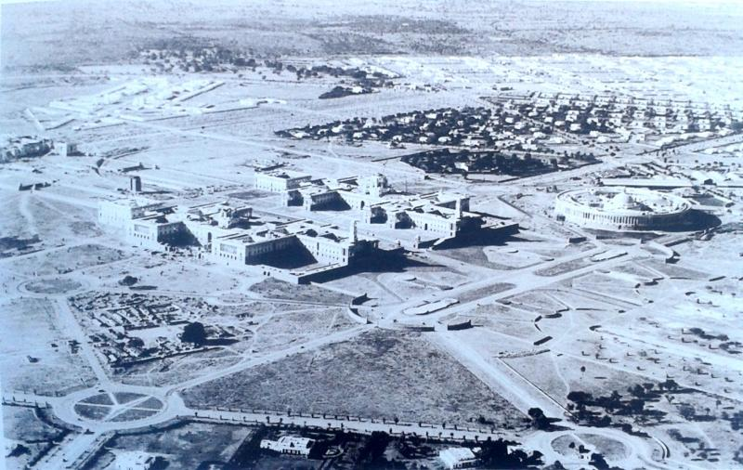

Malcha Mahal, Delhi ([source](https://upload.wikimedia.org/wikipedia/commons/c/cd/Construction_occuring_near_malcha_mahal_in_1920's_and_1930's_2014-03-21_09-44.jpg" \t "_blank))

The paranormal activities of Malcha Mahal are famous among the most haunted stories in the city of Delhi. The palace is situated in the forest area behind Buddha Garden. Reporters, forest officers or locals, all keep a fair distance and think twice before entering the premises. The warning related to the hound dogs and trespassers being gunned down (since the government gave the authority to shoot down anyone who proves to be a treat to the property) also scares people off this ground.

26. Three Kings Church, Goa

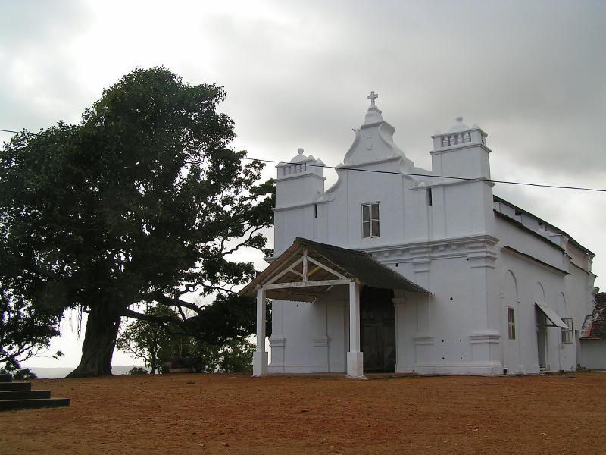

The Three King’s Church, Goa ([source](https://3.bp.blogspot.com/-vkRbAlz1SKE/TogbYsERM9I/AAAAAAAAAFo/hpzwX9LmlMI/s1600/Three+kings+chapel+-+Velsao.JPG" \t "_blank))

It is famous for its paranormal activities experience by many locals and also by the GRIP team of Indian Paranormal Society. It is believed that the spirits of three kings (who fought over the property of this church and eventually killed each other) roam around in the premises.

27. The Lambi Dehar Mines, Mussoorie

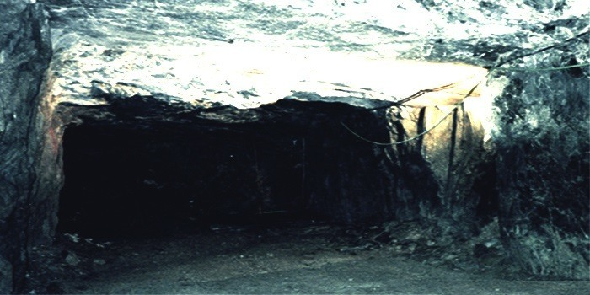

Lambi Dehar Mines, Musoorie ([source](http://24x7review.com/wp-content/uploads/2014/11/Lambi-Dehar-Mines-2.jpg" \t "_blank))

It is considered as one of the most haunted places in India. The mines were shut after half a million workers died coughing blood due to improper mining conditions. Locals believe that the place has turned into a home for a witch who walks down the hills at night and has claimed many life. Rapid occurrences of accidents and unusual deaths have also made this place rank amongst the spookiest places in the country.

28. Kalpalli Cemetery, Bangalore

[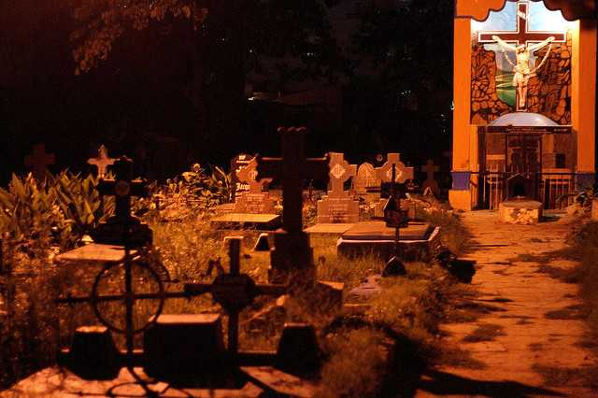](https://www.holidify.com/blog/wp-content/uploads/2015/08/kalpalli-cemetry.jpg)

Kalpalli Cemetery ([source](https://www.flickr.com/photos/jeet_sen/613553357/" \t "_blank))

Alternatively known as **St. John’s Cemetery** and located on the Old Madras Road, this place is as spooky as they come. Sighting of ghosts has often been reported by passerby and curious onlookers,  particularly of **a man like figure lurking about** on the premises. A stroll on a dark night is sure to send a shiver down your spine. Definitely not for the faint of heart.

29. The Mansion, Residency Road, Pune

[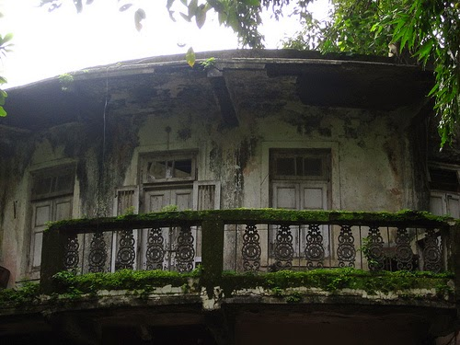](https://www.holidify.com/blog/wp-content/uploads/2015/08/haunted-house-pune.jpg)

The scariest houses have a strange pull

This old and dilapidated ruin of a **house is scary enough to look** at, leave alone venturing over there. According to the local tales, this place is haunted by an evil old lady. **Errie sounds, manic laughter and blood-curdling screams** are often heard late at night and easily makes it one of the **most haunted places in India**.  The **locals dread the place** and advice against going there. Some might just accept that as a challenge.

30. House Number W-3, Greater Kailash, Delhi

An abandoned house ([source](https://www.flickr.com/photos/nadircruise/7169014987/" \t "_blank))

This place and the story behind it seems to be **straight out of a horror flick**. A few years ago an elderly  helpless couple were murdered in cold blood in their own home. The house has since fallen to ruin but has retained it’s original occupants in some form or so the stories suggest. **Muffled laughter**, soft whispering and strange voices are heard every now and then. All this has cast a spell of fear and made this **one of the most haunted places in India**.

31. Vas Villa- St. Marks road, Bangalore

[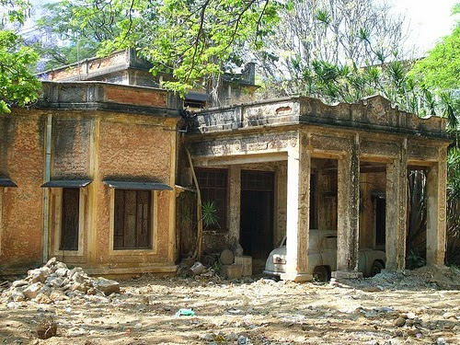](https://www.holidify.com/blog/wp-content/uploads/2015/08/haunted-mansion.jpg)

Vas-Villa, St. Marks Road, Bangalore ([source](http://bangaloreparanormalinvestigators.webs.com/" \t "_blank))

This place has a**tragic and violent past**. The place belonged to the Vas family and was occupied by Doice Vas and Vera Vas, the two daughters of the renowned lawyer, Mr Vas. On day in 2001, Doice was**stabbed to death** in her own home by an unknown assailant. She was later buried there as well and Vera moved out after some time. The place is in ruins and has been haunted ever since and **the spirit of Doice** is supoosed to still linger in the hallways. Multiple teams scouting for paranormal activities have **confirmed the presence of negative energy and disturbances.**

32. Savoy Hotel, Mussoorie

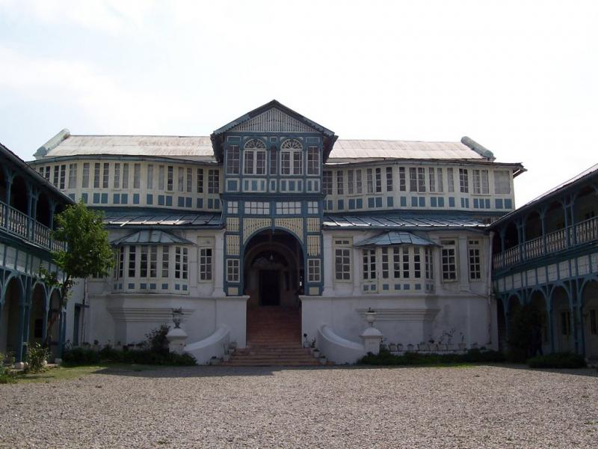

Hotel Savoy, Mussoorie ([source](http://pehchaanindia.com/wp-content/uploads/2015/05/1.jpg" \t "_blank))

The beautiful little hill-station of Mussoorie has it’s fair share of local legends, but **ghost of Lady Garnet Orme** takes the cake. She was found dead in one of the rooms of the Savoy hotel under **mysterious circumstances** and is supposed to haunt it ever since. Some say that she was poisoned and strychnine was discovered in one of her medicine bottles. The incident created quite a sensation and**Agatha Christie’s best-seller ‘The Mysterious Affair at Styles’** is supposedly basesd on this. Such a rich history ensures that it always finds a mention in the **list of most haunted destinations of India**. Hotel attendants and guests often complain of a lady in white walking the hallways and **strange noises and disturbances** coming from the room where she was murdered.

33. Khairatabad Science College, Hyderabad

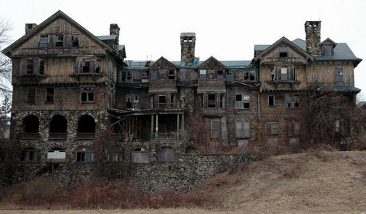

A college in ruins with a morgue. That’s creepy! ([source](http://www.theparanormalguide.com/uploads/1/7/3/8/17382059/6751076.jpg?507" \t "_blank))

There is an old inconspicuous **Tarapuri Buliding**, just off the Khairtabad flyover which used to be a science college. The building fell to ruin and was abandoned, but the **dead bodies in the bilogy labs** were not disposed off properly. People who pass by at night have often sighted **walking skeletons**, sparks and disturbing noises. A guard was stationed there by the Government but **he died mysteriously**, adding to the scariness of the place. Locals avoid this place and believe it to be one of the **most haunted** in the country.

34. Tunnel 33, Shimla

[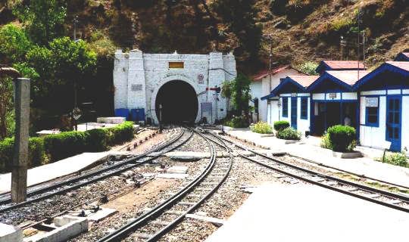](https://www.holidify.com/blog/wp-content/uploads/2015/08/Tunnel-33.jpg)

Tunnel-33, Barog, Shimla

Tunnel number 33 is the longest tunnel on the Shimla-Kalka railway stretch, situated **next to the Barog Train Halt**. Often claimed to be the straightest tunnel in the world, this feat of engineering has an interesting history. The task of construction was given to a British engineer named **Captain Barog** who failed to complete it. He was later fired from the job, mocked and driven to depression. One day he went into the tunnel and**shot himself**.

The tunnel was completed by someone else but named after him. Apparently his ghost still haunts the tunnel but is **a friendly one**. Locals also recount seeing a **woman run screaming into the tunnel** and a **man asking for matchsticks** to light his cigarette. Tunnels are inherently eerie places and a story like this is sure to make it **one of the most haunted ones**.

35. Chandan Nagar, Pune

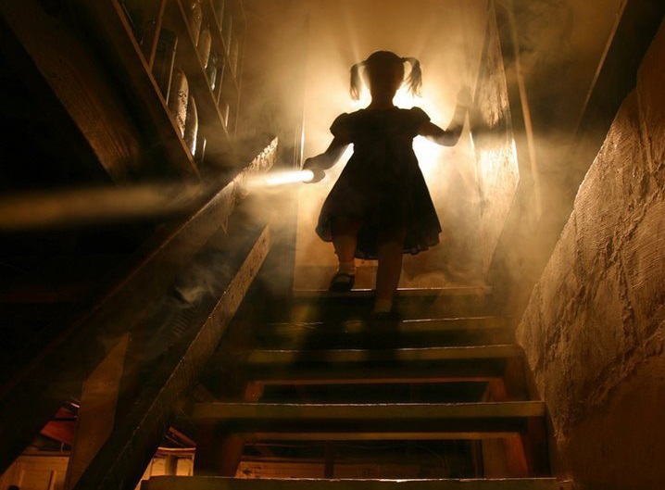

A little girl with a doll. How can that be scary? ([source](http://www.mississaugalife.ca/wp-content/uploads/2014/10/Scary-basement.jpg" \t "_blank))

The small colony of Chandan Nagar in Pune has a little terror hidden in it’s womb. The ghost of a little girl who roams the night**in a white frock, cradling a doll** in her hands! She appears at the strike of the midnight hour and comes screaming at you if you happen to cross her path. The very description is enough to make you jump out of your skin. There is story behind this. About 10 years ago the girl was **killed at a construction site** and has haunted the place since then. People have reported that **she smiles at you** if you look at her. This is good **fodder for a nightmare**, leave alone venturing to find her. Or should you?  
  
  
**You know what they say -See it to believe it!**

India is definitely a place of mysteries. For very long, people in the west have thought of India as a place of snake charmers and magicians. People have been visiting India to places like Varanasi, Rishikesh, Haridwar, etc. for spirituality. India has been the origin for 4 of World’s biggest religions: Hinduism, Buddhism, Sikhism and Jainism. And as they say, good spirits and bad spirits go hand in hand.

Indian Hindu mythology is full of devils and “Asuras” (demons). Time to time, various demons have rose and fought against angels and gods. According to hindu mythology, spirits never die and those spirits which die unnatural death can never find peace and keep roaming around, causing the place to be haunted. These free-roaming spirits have also been known to attack people, create unnatural incidents and make the places spooky.

These haunted places in India are just among the famous ones. Children in India grow up to listening to lots of stories from their grandmothers and some of them include haunted stories. Almost every village in India has a tree or a well which is supposedly haunted. A woman in white sari has been the typical image of spirits. I have spent so many nights discussing haunted stories with my friends and they always give me a chill in my spines, yet they are so much fun. I am sure you would also have heard of such stories or maybe created one ;)

In case you know of more haunted places or if you have experienced some paranormal activity yourself or know of haunted stories, please do share in the comments.

Haunted Places in India that just missed out on this list but are also reportedly haunted:

While compiling this list of the most horror inducing places across India, we came across a number of stories which we had no clue had any such history. Even more so, these are the regular places one visits without knowing what might be lurking at the next corner. And yet the thrill of not knowing what is to come makes it so much more interesting. These were some of the places that had some interesting stories that you might want to explore more.

**Jamali-Kamali Masjid, Delhi**

**Taj Mahal Hotel, Mumbai**

**Grand Paradi Towers, Mumbai**

**Lothian Cemetery, Delhi**

**Feroz Shah Kotla, Delhi**

**Gujarat Technological University (GTU) Campus, Ahmedabad**

**Bangalore International Airport Limited (BIAL), Bangalore**  
P.S.: This article has been compiled by studying various sources online and offline. The author and Holidify.com are not trying to create rumours or defame any place by writing about it.

Related Posts you might want to read:

[Haunted places in Mumbai](https://www.holidify.com/blog/haunted-places-in-mumbai/)

[Haunted places in Chennai](https://www.holidify.com/blog/haunted-places-in-chennai/)

[Haunted places in Delhi](https://www.holidify.com/blog/haunted-places-in-delhi/)

[Haunted Places in Pune](https://www.holidify.com/blog/haunted-places-in-pune/" \t "_blank)

[Bhangarh Fort Haunted](https://www.holidify.com/blog/bhangarh-fort-haunted/" \t "_blank)

[Haunted Places in Bangalore](https://www.holidify.com/blog/haunted-places-in-bangalore/" \t "_blank)

[Most Haunted Places in India](https://www.holidify.com/blog/most-haunted-places-in-india-asi-list/" \t "_blank)

Have you visited our website to [discover lesser known destinations for your travel plans?](https://www.holidify.com/)

Like the article? Please share on your social network. :)

**[https://holidify.com/images/social/fb-round.png](https://www.facebook.com/sharer.php?u=https://www.holidify.com/blog/most-haunted-places-in-india-asi-list/&t=35%20Most%20Haunted%20Places%20in%20India:%20Real%20Stories%20and%20places)[https://holidify.com/images/social/twitter-round.png?v=1.1](https://twitter.com/home?status=35%20Most%20Haunted%20Places%20in%20India:%20Real%20Stories%20and%20places:%20https://www.holidify.com/blog/most-haunted-places-in-india-asi-list/)[Get a Package](https://www.holidify.com/custom-package/?utm_source=blog&utm_medium=footer&utm_campaign=test)**

Similar Posts That You Might Like

* [Bhangarh Fort > Story Behind The Haunted Fort Perfect For short Trip](https://www.holidify.com/blog/bhangarh-fort-haunted/)Located at the border of the Sariska Tiger Reserve in […]
* [Haunted Places in Pune | Real Ghost Stories](https://www.holidify.com/blog/haunted-places-in-pune/)Dark, spooky, mysterious, mythical or the […]
* [15 Haunted Places in Delhi | Real Ghost Stories](https://www.holidify.com/blog/haunted-places-in-delhi/)“I asked my soul: What is Delhi? She replied: The […]
* [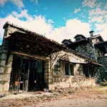Story of De Monte Colony in Chennai Will Give You Chills!](https://www.holidify.com/blog/de-monte-colony-chennai/)Everyone around (well, almost everyone) loves […]
* [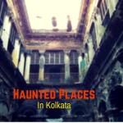Haunted Places In Kolkata | 12 Real Ghost Stories](https://www.holidify.com/blog/haunted-places-in-kolkata/)Ghosts, spirits and paranormal activities are […]
* [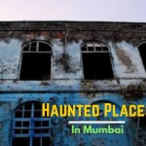Haunted Places in Mumbai | Real Ghost Stories](https://www.holidify.com/blog/haunted-places-in-mumbai/)Mumbai! The city of dreams and the city of gold is […]



**About [Holidify.com](https://www.holidify.com/blog/author/kovidkapoor/)**

[Holidify.com](https://play.google.com/store/apps/details?id=com.holidify.andorid.app.holidify&referrer=utm_source%3Dblog%26utm_medium%3Dauthor_profile) is the Highest Rated Travel App in India used to find holiday ideas. Download the app [here](https://play.google.com/store/apps/details?id=com.holidify.andorid.app.holidify&referrer=utm_source%3Dblog%26utm_medium%3Dauthor_profile) and you will be surprised to know that there are so many amazing destinations in India that you must visit.

« [Goa Beaches: 35 Best Beaches In Goa That You Must Visit](https://www.holidify.com/blog/best-beaches-in-goa/)

[17 Best New Year Destinations in India](https://www.holidify.com/blog/new-year-destinations-in-india/) »

Search our blog

Top of Form



Bottom of Form

Other Posts You Will Like

* [Kolkata Street Food: 20 Lip-smacking Places For Street Food In Calcutta](https://www.holidify.com/blog/street-food-in-kolkata/" \o "Permalink to Kolkata Street Food: 20 Lip-smacking Places For Street Food In Calcutta)

[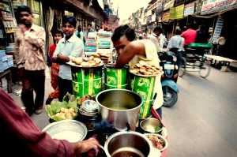](https://www.holidify.com/blog/street-food-in-kolkata/)

* [Dear Kolkata: You are my city](https://www.holidify.com/blog/dear-kolkata-you-are-my-city/" \o "Permalink to Dear Kolkata: You are my city)

[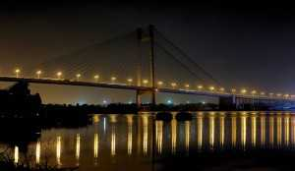](https://www.holidify.com/blog/dear-kolkata-you-are-my-city/)

* [10 Beaches In Goa To Get Away From The Crowd](https://www.holidify.com/blog/offbeat-goa-beaches/" \o "Permalink to 10 Beaches In Goa To Get Away From The Crowd)

[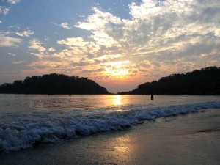](https://www.holidify.com/blog/offbeat-goa-beaches/)

* [Caves and Waterfalls in Chakrata: A secluded Wonder](https://www.holidify.com/blog/chakrata-caves-and-waterfalls/" \o "Permalink to Caves and Waterfalls in Chakrata: A secluded Wonder)

[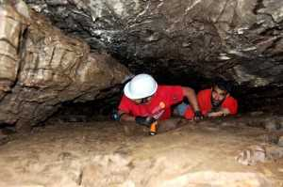](https://www.holidify.com/blog/chakrata-caves-and-waterfalls/)

* [Amarnath Yatra 2017 – Route and Dates](https://www.holidify.com/blog/amarnath-yatra-2017/" \o "Permalink to Amarnath Yatra 2017 – Route and Dates)

[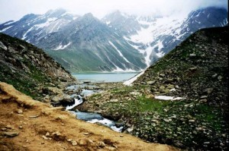](https://www.holidify.com/blog/amarnath-yatra-2017/)

* [Places to visit near Mumbai for summers](https://www.holidify.com/blog/places-to-visit-near-mumbai-for-summers/" \o "Permalink to Places to visit near Mumbai for summers)

[](https://www.holidify.com/blog/places-to-visit-near-mumbai-for-summers/)

* [Places to visit in Kolkata at night: Take the Kolkata nightlife by storm](https://www.holidify.com/blog/things-to-do-in-kolkata-at-night/" \o "Permalink to Places to visit in Kolkata at night: Take the Kolkata nightlife by storm)

[](https://www.holidify.com/blog/things-to-do-in-kolkata-at-night/)

* [Valentine’s Day Special: Offbeat Romantic Places in India](https://www.holidify.com/blog/best-less-crowded-romantic-destinations-india/" \o "Permalink to Valentine’s Day Special: Offbeat Romantic Places in India)

[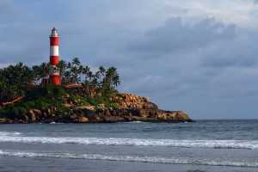](https://www.holidify.com/blog/best-less-crowded-romantic-destinations-india/)

* [Delicious Delicacies Of Manipur That You Should Not Miss!](https://www.holidify.com/blog/food-of-manipur/" \o "Permalink to Delicious Delicacies Of Manipur That You Should Not Miss!)

[](https://www.holidify.com/blog/food-of-manipur/)

* [Places to visit near Bangalore in Monsoon](https://www.holidify.com/blog/places-near-bangalore-for-monsoons/" \o "Permalink to Places to visit near Bangalore in Monsoon)

[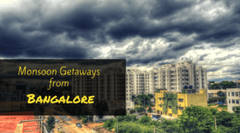](https://www.holidify.com/blog/places-near-bangalore-for-monsoons/)

Most Popular Posts

Also read [Jab Harry Met Sejal Shooting Locations To Fastrack Your Pending Europe Plans](https://www.holidify.com/pages/harry-met-sejal-shooting-locations-118.html)

* 25 Best Road Trips in India That You Must Take In 2017

[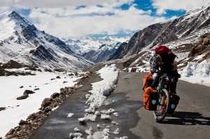](https://www.holidify.com/blog/best-road-trip-india/)

* Best Places For Solo Travel In India

[](https://www.holidify.com/blog/solo-travel-india/)

* Goa Beaches: 35 Best Beaches In Goa That You Must Visit

[](https://www.holidify.com/blog/best-beaches-in-goa/)

* Bhangarh Fort > Story Behind The Haunted Fort Perfect For short Trip

[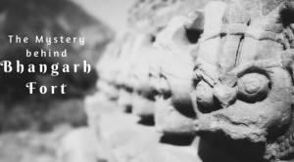](https://www.holidify.com/blog/bhangarh-fort-haunted/)

* Here Is A List Of Haunted Places in Rajasthan To Give You Serious Chills!

[](https://www.holidify.com/blog/haunted-places-in-rajasthan/)

Get CustomizedPackage

   
   
**[Submit](https://www.holidify.com/blog/most-haunted-places-in-india-asi-list/)**

© 2017 Holidify — All Rights Reserved.

[About Us](https://www.holidify.com/about-us/) | [Privacy Policy](https://www.holidify.com/privacy/) | [Terms of Use](https://www.holidify.com/terms-of-use/)